EXPERIMENT 16
Implement a Sobel Algorithm Using OpenCV to Filter the Input Image
Aim:
To apply the Sobel algorithm to detect edges in an image using Python and OpenCV.
Procedure:
- Import OpenCV and NumPy libraries.
- Read the input image.
- Convert the image into grayscale.
- Apply Sobel filters in X and Y directions.
- Display the original and filtered images.
Program:
import cv2

img = cv2.imread('image.jpg')
gray = cv2.cvtColor(img, cv2.COLOR_BGR2GRAY)

sobelx = cv2.Sobel(gray, cv2.CV_64F, 1, 0, ksize=3)
sobely = cv2.Sobel(gray, cv2.CV_64F, 0, 1, ksize=3)

cv2.imshow('Original Image', img)
cv2.imshow('Sobel X', sobelx)
cv2.imshow('Sobel Y', sobely)

cv2.waitKey(0)
cv2.destroyAllWindows()

Input:

Output:
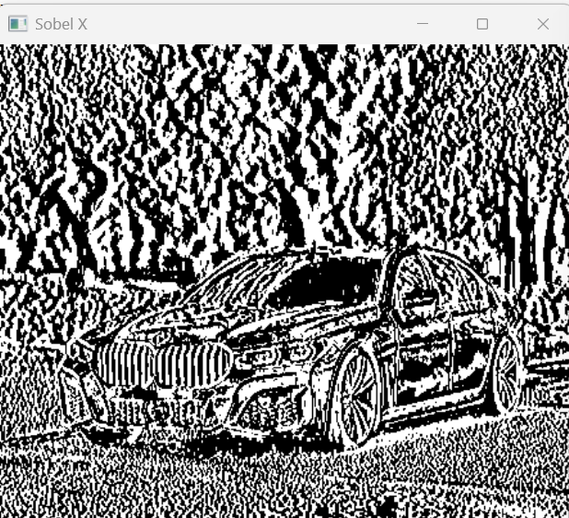
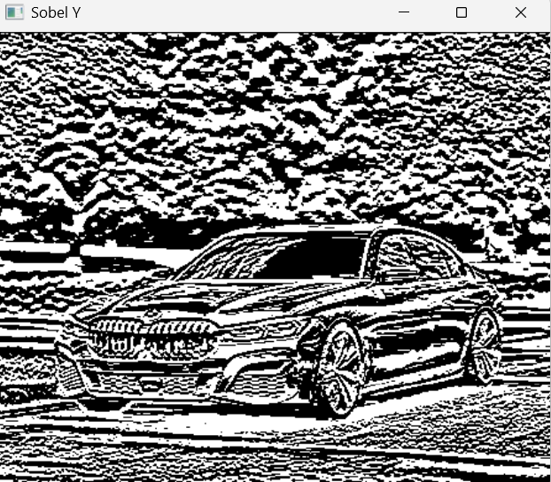
Result:
Thus, the Sobel algorithm was successfully implemented to detect edges in the input image using OpenCV.

